Drafting Direction No. 4.9  
Sections 53 and 56 of the Constitution—Bills and parliamentary amendments

Document release 1.3

Reissued September 2024

Contents

Part 1—Action summary 2

Part 2—Introduction 2

Part 3—OPC’s role 3

Part 4—Procedures 4

General description 4

What does the drafter need to do? 5

Section 53—Requests and amendments 5

Section 56—Bills and amendments requiring Governor-General’s messages 5

Amendments requiring Governor‑General’s message 6

What does the OPC Legislation area need to do? 8

Messages 8

Circulation of amendments 8

How to use standard documents 9

Part 5—Other documents dealing with parliamentary amendments 9

Attachment A—Diagrams for drafters and the Legislation area 11

Part 1—What does the drafter need to do with Senate amendments? 11

Part 2—What does the drafter need to do with House Bills and amendments? 12

Part 3—What does the OPC Legislation area need to do with Senate amendments? 13

Part 4—What does the OPC Legislation area need to do with House Bills and amendments? 14

|  |
| --- |
| Part 1—Action summary   1. This Drafting Direction describes certain actions that must be taken, and documents that must be prepared, if:    1. a parliamentary amendment is to be moved in the Senate as a request under section 53 of the Constitution; and/or    2. a Bill or parliamentary amendment requires a Governor-General’s message under section 56 of the Constitution. 2. To see what documents to prepare and what to do with them, go to:    1. paragraphs 22 to 37, and Parts 1 and 2 of Attachment A, if you are a drafter; or    2. paragraphs 39 to 41, and Parts 3 and 4 of Attachment A, if you are in the Legislation area. 3. The rest of this Drafting Direction provides more explanation of these documents. |

Part 2—Introduction

1. This Drafting Direction sets out the arrangements for dealing with parliamentary amendments, especially Senate amendments that should perhaps be moved as requests (Constitution section 53) and those that might require a Governor-General’s message (Constitution section 56). It also sets out the message procedures for Bills.
2. The reasons for these arrangements are as follows.
   * + The need to ensure that Ministers are aware of the relationship between sections 53 and 56 of the Constitution when they deal with OPC advice about the 2 sections.
     + The need to ensure that OPC’s role as an adviser to government, rather than an enforcer of certain constitutional positions, is recognised.
     + The Senate’s resolution on 26 June 2000 “That the Senate requires that all amendments circulated in the Senate chamber in the form of requests be accompanied by a statement of reasons for their being framed as requests together with a statement by the Clerk of the Senate on whether the amendments would be regarded as requests under the precedents of the Senate.”
     + A request from the Senate Clerk Assistant (Table) that we modify our previous procedures under which Ministers authorised the circulation of amendments, to remove a source of confusion and administrative problems.
3. Although none of these matters directly affects either Governor-General’s messages for Bills, or authority to circulate House amendments, procedures for these matters have been integrated with the arrangements.
4. There are various aspects of the arrangements.
   * + The heading for parliamentary amendments identifies only the sponsor of the amendments.
     + Our opinion that certain Senate amendments should be moved as requests is conveyed to Ministers explicitly, accompanied by an explanation of that opinion that will need to be circulated in the Senate (under its resolution of 26 June 2000) if the Minister accepts our advice and moves the amendments as requests.
     + Our opinion that certain Bills and amendments require Governor-General’s messages is conveyed to Ministers explicitly, accompanied by an explanation of that opinion.
     + The connection between the need to obtain a Governor-General’s message for an amendment and the need to move the amendment as a request in the Senate is conveyed to Ministers explicitly.
     + To ensure that these procedures do not have an undesirable effect on the management of government business in the parliament, we send documents indicating our views about messages and requests to the Parliamentary Liaison Officers (***PLOs***) in the House and the Senate respectively. The PLOs are members of the Department of the Prime Minister and Cabinet.
     + The drafter’s blocks for Bills and parliamentary amendments prompt drafters to comply with the procedures (see the drafter’s blocks in documents created using the bill_amd.dotx, bill_new.dotx and bill_pam.dotx templates).
     + The procedures also deal with how Ministers authorise the circulation of amendments.
5. In forming an opinion about section 53 or section 56 of the Constitution, and preparing advice for Ministers, we will be relying (until further notice) on constitutional advice.

Part 3—OPC’s role

1. OPC’s role in relation to sections 53 and 56 of the Constitution is to provide advice to the government about the application of those sections to Bills and parliamentary amendments that we draft. OPC does not have a role in ensuring that our advice is followed.
2. Providing advice to the government in this context will involve giving written advice, with explanations. The written advice will be addressed to Ministers, although copies of it should generally be provided to the instructing officers concerned.
3. Ministers may, if they wish, make our formal advice available to others, including officers of the Parliament. Furthermore, drafters may, on request from parliamentary officers, provide informal advice about the operation of particular Bills or amendments, to assist those officers to form their own views about whether section 53 or 56 might apply in relation to those Bills or amendments. However, I do not think it is our role to provide formal advice on section 53 or 56 except to the government. Nor is it our role to tell parliamentary officers what advice we have given Ministers.

Part 4—Procedures

General description

1. For the purpose of this Direction, and the associated documents, “sponsoring Minister” means the Minister with primary responsibility for the Bill. In general, the Legislation area will know who the sponsoring Minister is, but if there is any doubt it may be necessary to check with instructors or Ministers’ offices.
2. Finalised parliamentary amendments will not contain any indication of our view about whether the amendments should be moved as requests. The heading will simply indicate who is to sponsor the amendments (if we know). The parliamentary amendments template (bill_pam.dotx) will indicate that only this information should be included.
3. The same document is used for amendments drafted for consideration in the Senate, irrespective of our opinion about whether the amendments should be moved as requests.
4. Amendments drafted for consideration in the House of Representatives will also show only sponsorship information. The parliamentary amendments template (bill_pam.dotx) will indicate that only this information should be included.
5. If the drafter considers that a Senate amendment should be moved as a request to the House, advice to this effect, accompanied by an explanation of the advice and the complete set of amendments, must be emailed to the office of the sponsoring Minister. If that Minister is not handling the Bill in the Senate, a copy of the advice, explanation and amendments must also be emailed to the office of the Minister who is. The advice will be clearly identified as such, and will make it clear that the sponsoring Minister must choose whether to accept or reject the advice.
6. If the drafter considers that a Senate amendment requires a Governor-General’s message, advice to this effect, accompanied by an explanation of the advice and papers for the Minister to send to the Governor-General, must be sent to the office of the sponsoring Minister. This advice will be clearly identified as such, and will make it clear that the Minister needs to choose whether to accept or reject the advice.
7. If the drafter considers that a Senate amendment should be moved as a request AND requires a Governor-General’s message, both the request papers and the message papers mentioned above will draw attention to the connection between the request and the message in this case, and to the desirability of taking a consistent approach to the advice.
8. Where advice that an amendment should be moved as a request is given to a Minister or Ministers, the papers will point out that the Minister will need to indicate, on a certificate provided by the Senate, whether the amendment should be circulated as a request or not.
9. As indicated in paragraph 7, the procedures for arranging Governor-General’s messages for Bills and for House amendments will also require the drafter to prepare a brief explanation for our opinion that a message is required.
10. The procedures for authorising circulation of House amendments are much the same, with the document emailed by OPC to the office of the sponsoring Minister aligned in some respects with the Senate document.

What does the drafter need to do?

1. The following material is also set out in diagrams in Parts 1 and 2 of Attachment A.

Section 53—Requests and amendments

1. If the drafter considers (on the basis described in paragraph 8) that an amendment to be moved in the Senate should be moved as a request, the procedure below must be followed.
   1. Before the amendment is finalised, the drafter must prepare advice (the section 53 advice) that is about the need to move the amendment as a request and that consists of:
      * 1. a statement of reasons why the amendment should be moved as a request under section 53; and
        2. a letter to the sponsoring Minister’s senior adviser about section 53 (and also, if relevant, section 56).
   2. The section 53 advice can be generated by running the Section 53 Documents macro (see Word Note 5.2).
   3. When the amendment is emailed to the OPC Legislation area, or emailed to instructors on a contingency basis, the section 53 advice must be emailed to:
      * 1. the Bills Officer; and
        2. the office of the sponsoring Minister, and to the office of the Minister handling the Bill in the Senate (if those Ministers are different); and
        3. the PLO in the Senate and to the PLO in the House of Representatives; and
        4. the instructors (but note that this is not a substitute for providing the advice to Ministers).
2. The drafter must include a copy of the amendments (noting if not finalised) in the email to the appropriate Ministers’ offices, to the PLO in the Senate and to the PLO in the House of Representatives. It is the drafter’s responsibility to see that the section 53 advice goes to the appropriate Ministers’ offices and the Senate and House PLOs (not the Legislation area’s responsibility, and not the instructors’ responsibility).

Section 56—Bills and amendments requiring Governor-General’s messages

1. If the drafter considers (on the basis described in paragraph 8) that a Bill or amendment requires a Governor-General’s message under section 56 of the Constitution, the drafter must prepare advice (consisting of a statement of reasons) about the need for the message, as described in the following table and Word Note 5.2.

| **If the message is for:** | **Prepare the advice by:** |
| --- | --- |
| A Bill | Running the Section 56 Message Advice macro on the Bill document |
| An amendment to be moved in the House of Representatives | Running the Section 56 Message Advice macro on the parliamentary amendment document |
| An amendment to be moved in the Senate (which should be moved there as a request) | Running the Section 53 Documents macro on the parliamentary amendment (request) document, then running the Section 56 Message Advice macro on the statement of reasons why a Governor-General’s message is required, if it is desired to include standard text for the reasons in the statement |

1. The drafter must email the advice to the OPC Legislation area as soon as possible after the Bill or the amendment is lodged for LAP (or, if an urgent amendment will not be lodged for LAP, as soon as possible after the amendment is finalised).

Amendments requiring Governor‑General’s message

1. The view of the House of Representatives is that only a Minister may move amendments in the House if the amendments require a message under section 56 of the Constitution.
2. The procedural requirements for parliamentary amendments requiring a Governor‑General’s message under section 56 of the Constitution can give rise to issues of timing in dealing with the amendments in Parliament.
3. This is because of House of Representatives Standing Orders 180 and 181, which provide:

180 Appropriations recommended by Governor‑General

(a) All proposals for the appropriation of revenue or moneys require a message to the House from the Governor-General recommending the purpose of the appropriation in accordance with section 56 of the Constitution.

(b) For an Appropriation or Supply Bill, the message must be announced before the bill is introduced.

(c) For other bills appropriating revenue or moneys, a Minister may introduce the bill and the bill may be proceeded with before the message is announced.

(d) A further message must be received before any amendment can be moved which would increase, or extend the objects and purposes or alter the destination of, a recommended appropriation.

181 Message for Senate amendments and requests

Any message from the Governor-General recommending an appropriation in relation to a Senate amendment or request for amendment to a House bill, must be announced before the House proceeds to consider the amendment or request.

1. Standing Orders 180(d) and 181 have the effect that an amendment that requires a message may not be moved in, or otherwise dealt with by, the House of Representatives unless the message has been obtained and is available to the House of Representatives.
2. The third reading of a Bill in the House of Representatives usually takes place immediately after amendments are dealt with (in contrast to the Senate, where committee consideration of a controversial Bill may continue over a period of days or even weeks), and the Bill has then “passed” the House (see Standing Order 155(c), which provides that “After the third reading the bill has passed the House and no further question may be put.”). To ensure that section 56 of the Constitution, which also refers to proposed laws being passed, is not breached in relation to provisions inserted by parliamentary amendments, the Clerk of the House of Representatives takes the view that there is no scope for moving to suspend Standing Order 180(d) or 181 in relation to a parliamentary amendment for which a required message is not available.
3. On occasion, this may mean that last-minute amendments cannot be moved in accordance with the Minister’s wishes—in particular, if an amendment requiring a message only surfaces late at night, debate on the Bill may have to be deferred until a message can be obtained the next day.
4. There are several things drafters can do to limit the risk of Ministers being thwarted in relation to moving parliamentary amendments requiring messages.
5. You should email a copy of parliamentary amendments (or requests) to the Legislation area each time final (settled) copies are given to instructors.
6. When you draft amendments requiring a message out of normal working hours, you should advise your instructors:
   1. that the amendments may not be moved until the message is available; and
   2. that it may not be possible to obtain a message until the next working day.
7. If your instructors suggest that moving the amendments in the House of Representatives (whether or not as a result of the amendments being moved as requests in the Senate) is genuinely urgent, you should try to contact a member of staff in the Legislation area or First Parliamentary Counsel to see if a message can be arranged (remembering that even if one of us can be prised from our beds at midnight, the Governor-General’s staff may not be keen to wake the Governor-General). When the amendments are settled, you should, except where paragraph 37 applies, also email a copy of the amendments to the Director—Programming, in the Table Office in the House of Representatives (see Word Note 6.8 for contact details).
8. If you are asked to draft “back-pocket” amendments (i.e. amendments that the Minister might wish to move but is not ready to commit himself or herself to) that require a message, you should follow essentially the same procedures, modified as follows:
   1. During normal working hours, email copies to the Legislation area, but note on the copies that the amendments are still subject to Ministerial approval.
   2. Tell your instructors about the need for a message and that the OPC Legislation area will arrange the message.
   3. If the instructors are unwilling to have the message arranged (perhaps because the Minister is unwilling to commit himself or herself to the extent of signing the necessary letter to the Governor-General), tell them that the amendment will not be able to be moved without the message and that the message may not be able to be obtained at short notice, especially out of normal working hours. In some cases, you may think it wise to put this advice in writing.
9. You should consult with FPC as soon as possible if you become aware that the Government is considering moving in the Senate amendments that require a message but which the Senate considers should be moved as amendments, not requests.

What does the OPC Legislation area need to do?

1. The following material is also set out in diagrams in Parts 3 and 4 of Attachment A.

Circulation of amendments

1. The letter to be sent to the sponsoring Minister asking the Minister to authorise circulation of amendments in the Senate reminds the Minister that the Minister will need to indicate to Senate officers whether any of the amendments should be circulated as requests.
2. The equivalent letter for House amendments is aligned with the Senate letter.
3. The standard letter sent to the sponsoring Minister can be prepared by clicking on Msg/Notice on the OPC Admin toolbar.

Messages

1. The standard letter to send to a Minister’s office about a Governor-General’s message can be prepared by clicking on Msg/Notice on the OPC Admin toolbar. This must be accompanied by the letter from the Minister to the Governor-General, and the message itself. It must also be accompanied by the drafter’s statement of reasons for advising that a message is required.
2. Whenever message papers are sent to a Minister’s office, a copy of the covering letter (but not the Minister’s letter or the message itself) must be emailed by a Bills Officer to the PLO in the House of Representatives.

Requests

1. A parliamentary amendment is identified as needing to be moved in the Senate as a request if it:
   1. amends a Bill that imposes taxation; or
   2. amends a proposed law appropriating revenue or moneys for the ordinary annual services of government; or
   3. increases a charge or burden in relation to an appropriation; or
   4. increases a charge or burden in relation to the rate of tax or the tax base.
2. Only those parliamentary amendments relating to an appropriation (as referred to in paragraph 45(b) or 45(c)) also require a message. The standard letter for a message must be used in this case. This can be prepared by clicking on Msg/Notice on the OPC Admin toolbar.
3. For any parliamentary amendment that is identified as needing to be moved in the Senate as a request (whether or not it requires a message), a copy of the section 53 papers that the drafter has emailed to the office(s) of the Minister(s) must be attached to the letter in addition to the accompanying papers mentioned in paragraph 43.
4. The procedures set out in paragraph 23 should ensure that the Minister will also receive the request advice from the drafter, but attaching that advice to the message letter ensures that the Minister’s office will see the two sets of documents together.

How to use standard documents

1. The convention that has been adopted in relation to the standard documents is as follows:
   * + Material that needs to be customised when a document is prepared is indicated in square brackets.
     + Material in square brackets that will or may need to be omitted, or retained with the square brackets removed, is in roman type. Note that the square bracketed headings to most of the documents, which set out the case in which the document is to be used, should be omitted in preparation of a customised document.
     + Material in square brackets that will need to be customised is in italic type.

Part 5—Other documents dealing with messages and parliamentary amendments

1. The following table identifies some other documents dealing with procedural and other matters relating to messages and parliamentary amendments.

| **Procedural and other matters that relate to messages and parliamentary amendments and are dealt with in other documents** | | |
| --- | --- | --- |
| **Item** | **This matter:** | **Is dealt with in this document:** |
| 1 | The requirement to obtain a message when statutory offices are established | Drafting Direction 3.6 |
| 2 | Amendment of Bills on return to originating House | Drafting Direction 4.8 |
| 3 | Revised versions and replacement of amendments already circulated in the Parliament | Drafting Direction 4.8 |
| 4 | Limits on what provisions can be inserted or amended by a single parliamentary amendment | Amending Forms Manual |
| 5 | Amending forms for parliamentary amendments | Amending Forms Manual |
| 6 | Sending finalised amendments to Parliament (with special procedures for Senate amendments) | Word Note 6.8 |

Meredith Leigh  
First Parliamentary Counsel

16 September 2024

| **Document History** | | |
| --- | --- | --- |
| **Release** | **Release date** | **Document number** |
| 1.0 | 1 May 2006 | s06pf336.v01.doc |
| 1.1 | 1 September 2014 | s06pf336.v07.docx |
| 1.2 | 24 May 2019 | s06pf336.v18.docx |
| 1.3 | 16 September 2024 | s06pf336.v23.docx |

Note: Before the issue of the current series of Drafting Directions, this Drafting Direction was known as Drafting Direction No. 10 of 2004.

Attachment A—Diagrams for drafters and the Legislation area

Part 1—What does the drafter need to do with Senate amendments?

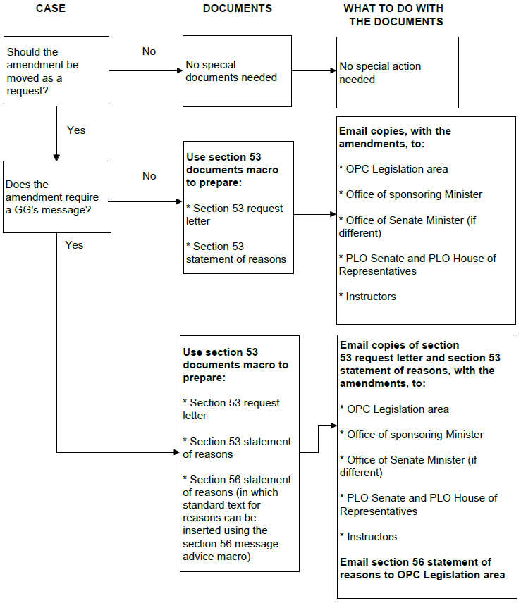

Part 2—What does the drafter need to do with House Bills and amendments?

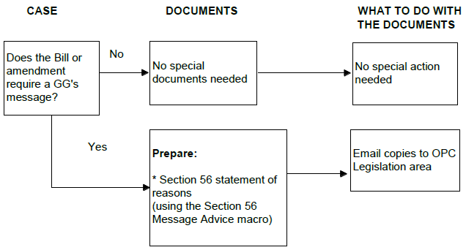

Part 3—What does the OPC Legislation area need to do with Senate amendments?



Part 4—What does the OPC Legislation area need to do with House Bills and amendments?