For the period 2024-25 to 2027-28

2024-25

Corporate Plan

OFFICIAL

**OPC snapshot 2024-25**





1.00

**Total no. of in force items on the register**

TB

75,546

**Pages checked by editorial**

31,438

**Size of register**



**Number of visits to the register**

**In Force**

**31,438**

**Not In Force**

**76,079**

**Total number of items on the register**

13.3MILLION





1,750

**No. of compilations published**

17,012

586,102

**No. of pages of compilations published**

**Total no. of gazettes on the register**



**Workforce by years at OPC**

**0-5 Years**

**52%**

**20+ Years**

**8%**

310

3,380

**Pages in total**

x

**No. of legislative instruments made**

**No. of Bills Introduced**

135

**Introduction**

**6-10 Years**

**26%**

**11-20 Years**

**14%**

**Pages in total**

6,177

The Office of Parliamentary Counsel (***OPC***) plays a role at the centre of Government, drafting and publishing Commonwealth legislation for all Australians.

We are a team of dedicated specialists, with deep expertise in drafting and publishing legislation. With our focus on the statute book as a whole, we have the opportunity to work across all subject matters, and the privilege of working with many Commonwealth agencies.

OPC’s 2024-25 Corporate Plan covers the periods 2024-25 through to 2027-28.

This plan has been prepared, in accordance with the *Public Governance and Accountability Rule 2014*, under paragraph 35(1)(b) of the *Public Governance, Performance and Accountability Act 2013* (the ***PGPA Act***).

This plan sets out OPC’s mission and purposes, the key activities that OPC will undertake to achieve its purposes, the context in which we work, and how we will measure our performance in achieving our purposes over the period of the plan. It also addresses our key risks and our strategies to mitigate those risks.

This plan is a central part of our business planning and performance framework.

OPC will report progress on this plan through the annual performance statements in the Annual Report, as required by subsection 38(1) of the PGPA Act.

Meredith Leigh  
First Parliamentary Counsel  
August 2024

**Our mission**

**OPC’s mission is to provide clear, effective and accessible Commonwealth law for all Australians.**

**Our purposes**

OPC’s purposes are:

* to enable the Government to implement its legislative program by drafting Commonwealth Acts, and Executive Council and other legislative instruments; and
* to ensure Commonwealth laws are freely available and accessible to all Australians by publishing Commonwealth laws on the Federal Register of Legislation.

**Our key activities**

The key activities that OPC will undertake in order to achieve our purposes are:

Drafting high quality Bills and instruments

Registering, compiling, and delivering for tabling, legislative and other instruments

Managing the Federal Register of Legislation

***Drafting high quality Bills and instruments***

The functions of OPC under the *Parliamentary Counsel Act 1970* include drafting proposed laws, amendments and subordinate legislation. Our dedicated focus on drafting Bills and instruments allows us to ensure that the legislation we draft is of a high quality.

Our drafters are not merely scribes who write policy as a series of rules. Instead, our drafters work with agencies across the Australian Public Service (the ***APS***) to help them to develop their policy, simplify their policy to the extent possible, and ensure that legislation is legally effective. Through this process our drafters aim to draft legislation in a way that is as clear and easy to understand as possible.

***Registering, compiling, and delivering for tabling, legislative and other instruments***

***Managing the Federal Register of Legislation***

One of the objects of the *Legislation Act 2003* includes establishing the Federal Register of Legislation as a permanent repository of versions of Acts, legislative and notifiable instruments, and compilations of such Acts and instruments.

We manage the Federal Register of Legislation by registering, and providing certain information on, Acts and instruments. It is essential that the Australian public can see up-to-date versions of our laws, and we contribute to this by producing and registering compilations of Acts and some legislative and notifiable instruments.

The ability of the Parliament to disallow instruments is a central feature of Australia’s democratic system. Under the *Legislation Act 2003*, OPC is responsible for ensuring that legislative instruments are delivered to the Parliament for tabling.

Our structure

To achieve our purposes, we work across three broad workgroups:

* + - Drafting workgroup
    - Publications workgroup
    - Corporate services workgroup

**Second Parliamentary Counsel**

Bronwyn Livermore

**Second Parliamentary Counsel**

Rebecca Considine

**First Parliamentary Counsel**

Meredith Leigh

**Our values**

OPC staff uphold and promote the APS Values outlined in the *Public Service Act 1999*. OPC is a values-driven agency, and we have collaborated to develop a set of OPC values. We demonstrate these values daily to achieve our purposes:

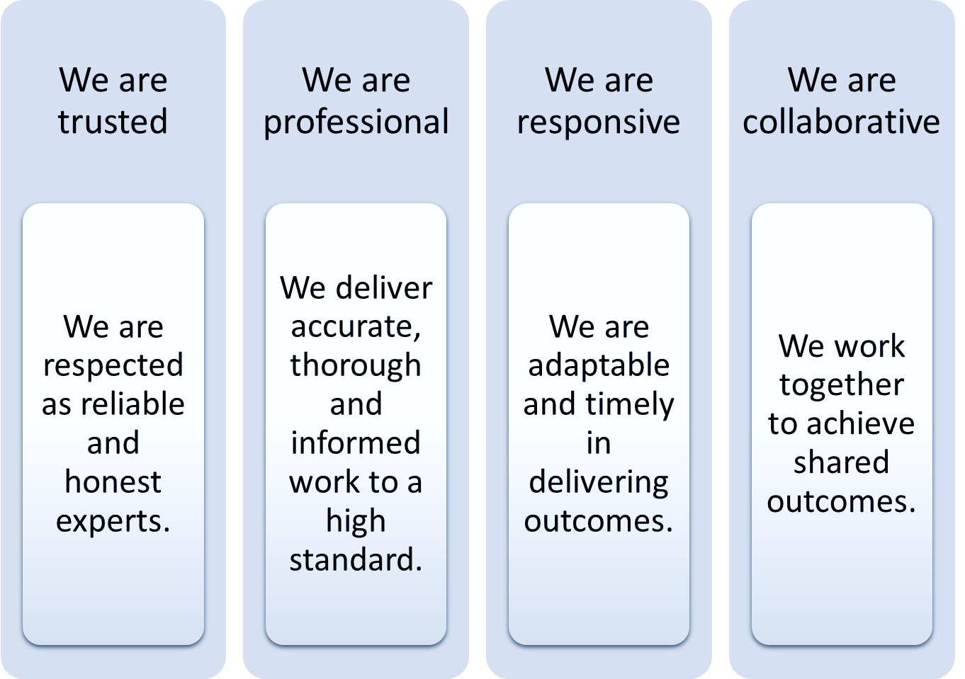

**About us**

OPC is a non-corporate Commonwealth entity established under the *Parliamentary Counsel Act 1970*, within the Attorney-General’s portfolio, and reporting to the Attorney-General. As a small, specialised agency focused solely on legislative drafting and publishing, we are able to perform our functions in a way that delivers high quality products extremely efficiently.

About half of our 120 staff are legislative drafters, responsible for drafting Commonwealth Bills and legislative instruments. About a third of our staff work in our Publications group, with responsibility for editing, registering and compiling all Commonwealth Acts and some legislative and other instruments, and tabling legislative instruments. The Acts and instruments are registered on the Federal Register of Legislation, which is a complete Register of all Commonwealth Acts and legislative instruments. The remaining staff are our corporate services staff who support us to achieve our purposes.

OPC has a long history, with 54 years as a statutory agency focussed solely on Commonwealth legislation.

OPC’s focus is on the full life cycle of legislation (both Bills and subordinate instruments) through the Parliament, and onto the Federal Register of Legislation, so that the public may access all Commonwealth laws. We provide a high quality legislative drafting service, recognising that Commonwealth laws, whether primary or subordinate, operate as a whole. The Federal Register of Legislation is a permanent record of all Commonwealth Acts and legislative instruments, reflecting the issues of the day since Federation.

**The context in which we work**

There are many factors, both internal and external, which impact on OPC and how we operate.

Our environment

**General**

We are committed to flexible working, but we also have a strong understanding of the strengths of coming together in one location. We are continuing to pursue different technologies that allow us to work more effectively into the future.

In these uncertain times, the Government frequently needs to respond as new challenges arise, pivoting to focus on different subject areas and pieces of legislation to deal with these challenges. OPC drafters deal with the entire statute book. When new challenges emerge, we collaborate with Departments and agencies who bring knowledge of their particular legislation, just as we bring knowledge of the whole statute book, and in doing so, support the Government to deal with these new and emerging issues.

The rapidly changing information technology world in which we live provides both threats and opportunities. Cybersecurity will remain a focus, but artificial intelligence will provide opportunities to be explored.

Throughout the Australian Public Service, there is a renewed focus on stewardship, APS reform, and stamping out corruption. We will continue to embed the APS values and our own OPC values to ensure that OPC embodies the vision of a modern, high performing public service that displays integrity. For the SES, 2024-25 will see an additional focus on embedding the APS Secretaries’ Charter of Leadership Behaviours (DRIVE).

In a challenging employment market as we have had over the past few years, it is important to be an employer of choice, recruiting and retaining excellent staff across the office. We have a strong focus on our workplace culture, and building a collaborative and collegiate culture across the whole office. This, as well as the changes occurring through the APS reform, makes OPC an exciting and rewarding place to work.

Drafting work

OPC’s drafting work is regulated by the *Legal Services Directions 2017*. All Commonwealth Bill and regulation drafting is tied to OPC and budget funded. OPC also drafts other legislative instruments for government clients on a fee-for-service basis.

OPC’s drafting work is done by highly skilled lawyers working in small team arrangements. The small team arrangements serve two purposes: producing the legislation required for today, and discharging our role as stewards of OPC by training the drafters of tomorrow. It is critical to OPC’s ability to meet short term demands, and for the long term functioning of the Office, for OPC to recruit, train and retain highly skilled drafters.

OPC performs a role that is central to the functioning of government and delivering the government’s legislative agenda. Among other things, we raise issues that relate to broader government policy, and ensure that certain areas of the government with relevant policy responsibility are consulted about proposed legislation.

First Parliamentary Counsel (***FPC***) also has an obligation under section 16 of the *Legislation Act 2003* to encourage high standards in the drafting of legislative instruments. FPC has worked on a number of initiatives to achieve this, including developing courses provided by drafters which aim to build instructing and drafting capability within other agencies. We are also focussed on providing more publicly available materials, such as our Instrument Fact Sheet Series, which we launched in 2023.

The rapid change of information technology has highlighted some of the areas where legislation was ill-prepared for the digital age. We will continue to work with Departments and agencies to design and draft legislation that is fit-for-purpose in the digital age in which we live.

Publications work

The Federal Register of Legislation contains all Commonwealth Acts and legislative instruments (both current and historical), notifiable instruments, Gazette notices, and some related information. The Commonwealth is one of only 2 jurisdictions in Australia to have a comprehensive register that contains not only all Acts, but also all legislative instruments (irrespective of the kind of legislative instrument).

The comprehensive nature of the Federal Register of Legislation is a huge asset to the Australian public, who are able to access the entire statute book in a single place.

However, OPC is responsible for drafting only about 30% of all subordinate instruments. The diversity of instruments registered across the government raises challenges, and a key part of OPC’s role is to support Departments and agencies as they draft and register their subordinate legislation. OPC does this by providing templates, guidance and training in relation to subordinate instruments.

The new Federal Register of Legislation was launched on 1 January 2024. The redevelopment was an opportunity to increase the efficiency, useability, functionality and responsiveness of all levels of the Federal Register of Legislation. It was also an opportunity to review current technologies to ensure the Federal Register of Legislation remains technologically viable into the future.

We also recognise that a comprehensive and complete Register underpins the rule of law and Australia’s vibrant democracy. Our laws are part of the fabric of our society and are important to so many: lawyers, judges, librarians, historians, public servants, private sector and non-government organisations, and members of the public. We are always working to complete some of the historical gaps on our Register to ensure that our data is accurate and comprehensive. The current focus is on creating compilation versions for Acts and Regulations for historical points-in-time. In addition to this, a project to make older Gazettes more accessible is being developed.

With an increased focus on diversity, our drafting and publications staff have collaborated on a policy to ensure we comply with Web Content Accessibility Guidelines in providing alternative text for Commonwealth legislation. This has resulted in Drafting Direction 1.9, which is on OPC’s website. This policy is now embedded in OPC and we continue to promote the policy to other agencies drafting their own subordinate instruments.

Cooperation

The APS Reform will continue to focus, among other things, on coming together. This increased focus on cooperation and collaboration demonstrates that the whole is greater than the sum of the parts.

We will continue this focus, building closer relations with a number of key external stakeholders. These include the Attorney-General’s Department, the Treasury, and the Departments of Agriculture, Fisheries and Forestry, Finance, Health and Aged Care, Home Affairs, Social Services, and Prime Minister and Cabinet. Through this cooperation and collaboration we improve our ability to deliver on our purpose of enabling the Government to implement its legislative program.

OPC will continue our close ties with a range of areas within the Attorney-General’s Department on matters of mutual interest. FPC will continue to be a member of the Department’s Legislation Committee and the Significant Legal Issues Committee. FPC is also an ex officio member of the Board of Tax, with the Department of the Treasury, the Australian Taxation Office and private sector members. Finally, FPC is a member of the Australasian Parliamentary Counsel’s Committee.

The redevelopment of the Federal Register of Legislation gave us an opportunity to bring together a stakeholder group from across the APS and the private sector to support us in designing the public website for the Federal Register of Legislation. We look forward to continuing this engagement as we start thinking about future improvements to our Register.

Within OPC, we focus on collaboration and cooperation through our Consultation and Engagement Framework. This framework establishes a number of Committees (the People Committee, the Business Operations and Innovation Committee and the Joint Publications and Drafting Working Group), ensuring that OPC staff have a direct voice in matters affecting OPC.

**Capability**

Our staff are our most important asset, and investing in our staff is one of our highest priorities. We do this through recruiting and retaining great people. We invest heavily in our staff through our modern and flexible performance program (the Achieving Capability and Excellence (ACE) Program), extensive on-the-job training and development, a focus on peer-to-peer learning at all levels, as well as through online and other methods of formal training. We offer personal and professional support to our staff, and focus on providing a supportive, inclusive and flexible work environment.

We are continuing to focus on building capability across the entire organisation in relation to our key activities:

Drafting high quality Bills and instruments

Registering, compiling, and delivering for tabling, legislative and other instruments

Managing the Federal Register of Legislation

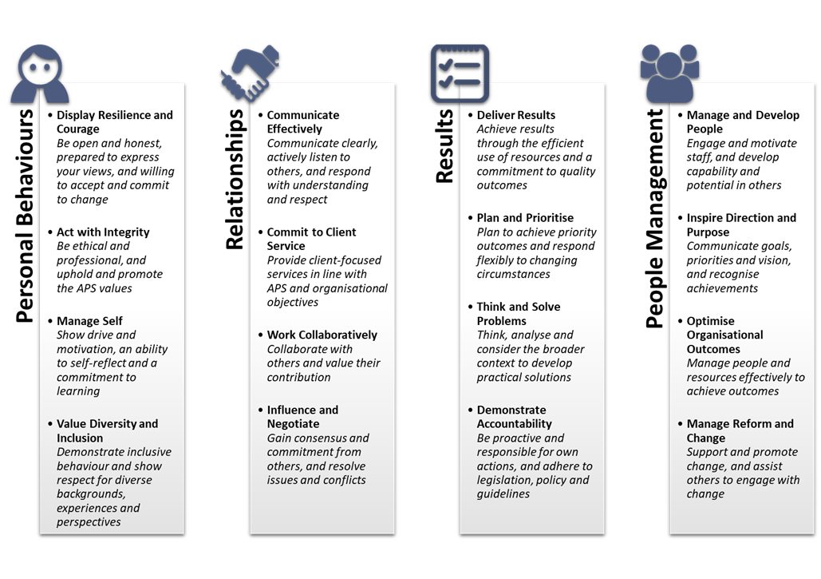OPC’s core capabilities bring together our focus on technical excellence, while also recognising other essential behaviours that underpin the success of each of us in the workplace.

In 2024-2025, we will continue this focus on building capability with the following initiatives:

* + - We will implement and promote the new APS Value of Stewardship. We will continue to build our capability and institutional knowledge to support the public interest now and into the future. We will continue to ensure that all our people understand the long-term impact of what we do. In addition, we will continue to focus on integrity, ensuring that our policies and practices reflect an emphasis on the promotion of ethical behaviour and a culture of reporting behaviour that is fraudulent or corrupt;
    - We will implement a comprehensive supervisor skills training program, encompassing all supervisors, providing a solid foundation for new and potential supervisors, and creating an extension program to focus on growth for selected supervisors;
    - We will continue to embed and build our feedback culture throughout OPC. We will implement with SES Performance Leadership Framework, encouraging leadership in seeking feedback from multiple sources on both behavioural capabilities and outcome delivery;
    - We will continue the successful implementation of Assistant Parliamentary Counsel Development Managers, overseeing the long term development of our assistant drafters);
    - We will continue to provide training in the Drafter workgroup through the pairing system where experienced and newer drafters are teamed together, and through the role of the Director of Drafting Training;
    - We will continue to maintain a dedicated training officer to provide training in the Publications workgroup, ensuring cross-skilling across the workgroup;
    - We will continue to invest in our technologies and provide modern tools to create efficiencies and build our capability to work collaboratively.

Our APS Census results from 2023 highlighted three (3) action and monitoring areas -

***Technology, tools and processes*** - We are modernising our information technology platforms without losing the efficiency advantages that our bespoke systems have given us.

***Change*** -We are working to support our people to identify and adapt to more modern and sustainable ways of working, with a particular focus on adapting to the modern information technology platforms that will be implemented.

***Workloads*** -While we have mechanisms in place to ensure our workloads are safe, we will continue to address this issue. We will implement the ‘right to disconnect’ changes to the *Fair Work Act 2009*, developing guidance to help employees and supervisors to be clear about when it is and is not OK to connect. We will continue to consider what else we can do to manage our workloads to prevent exhaustion and ensure psychological safety.

**Risk oversight and management**

OPC is continuing to embed policies and processes, practical tools and techniques, to support our approach to managing risk. We are also focussed on building capability in relation to risk management.

OPC’s risk management framework is aligned with the Commonwealth Risk Management Policy.

Overall accountability for risk management rests with FPC. The Senior Management Team is responsible for developing, implementing, and managing our Risk Management Framework, and for identifying and managing identified enterprise level risks. OPC also draws on the deep experience and expertise relating to risk from our members of the Audit and Risk Committee.

Our Senior Management Team actively review identified enterprise level risks and associated mitigation strategies, along with our appetite and tolerance towards risk.

Key staff who engage more actively with significant risks have undertaken advanced risk training and are involved with facilitating discussions across the office in relation to risk management.

**Table 1: Enterprise risks and risk mitigation strategies**

|  |  |
| --- | --- |
| **Enterprise risk** | **Risk mitigation strategy** |
| **People** |  |
| Attraction and Retention - Failure to attract and retain talented staff and future leaders | A strong culture of building capability  A clear understanding of roles  Competitive remuneration and other conditions  A culture of staff engagement |
| Risks to our staff’s health, safety and wellbeing | A rigorous culture of work health and safety, with a regular review of risks, policies and performance |
| **Delivery** |  |
| Failure to comply with statutory or other obligations | Clear, embedded and up-to-date policies  Regular staff training  Appropriate staff resourcing  Regular compliance reporting |
| Failure to be able to deliver our drafting function | Active recruitment of drafters  Strong culture of drafter training  Drafter pairing system and second reading for all drafts  Active monitoring of workload  Legislation program and assistance to agencies to manage legislation programs |
| Failure to be able to deliver our publishing functions and services | Appropriate resourcing of Publications staff  Cross-skilling staff  Active monitoring of workload  Active engagement with stakeholders |
| The Federal Register of Legislation (***FRL***) fails to provide comprehensive and free access to Commonwealth legislation | Active management of FRL  Embedded security compliance practices for FRL, such as penetration testing and IRAP assessments  Business continuity arrangements |
| An unplanned disruption to our technology and infrastructure | Strategic and business plans covering ICT  Embedded security compliance practices  Appropriate resourcing of ICT staff  Up-to-date policies and practices |
| **Ethical behaviour** |  |
| Fraudulent or corrupt behaviour by a staff member and/or a third party, resulting in reputational damage and financial loss | Up-to-date policies and appropriate practices  Setting clear expectations in relation to fraudulent and corrupt behaviour, including regular training on fraud and corruption  Annual disclosure of material personal interests  Reporting mechanisms for fraud and corruption |

As part of the suite of APS reforms, amendments to the Commonwealth Fraud Rule (section 10 of the *Public Governance, Performance and Accountability Rule 2014*) come into effect from 1 July 2024. Under the new Commonwealth Fraud and Corruption Rule, entities will be required to take measures to prevent, detect and deal with corruption, alongside existing counter-fraud requirements. The changes to the Commonwealth Fraud Rule, and the implementation of the new Commonwealth Fraud and Corruption Control Framework from 1 July 2024, complement the establishment of the National Anti-Corruption Commission.

OPC is continuing to embed policies and processes, practical tools and techniques, in regard to its integrity framework. This will provide the building blocks for a pro-integrity culture, which will produce better decision-making, exemplify high professional standards, enhance public trust in OPC, and protect against misconduct. A mature integrity culture allows us to deliver our strategic objectives ethically and efficiently.

This framework will apply to all OPC staff, contractors, and third parties undertaking services on behalf of OPC.

**Performance**

OPC’s current performance measures have been published in the 2024-25 Portfolio Budget Statements.

Below is a summary, for each reporting period, of the planned performance measures and targets to be used to assess the performance of OPC and its significant activities over the period of the Plan.

| **Summary of planned performance** | | | | | |
| --- | --- | --- | --- | --- | --- |
| **Performance criteria** | **Performance measure** | **2024-25** | **2025-26** | **2026-27** | **2027-28** |

|  |  |  |  |  |  |
| --- | --- | --- | --- | --- | --- |
| **Legislative drafting**  Drafting teams deal with each stage in the drafting process in a timely way | Proportion of clients who agree, having regard to the priority allocated to their project, that drafting teams deal with the drafting process in a timely way | 95% | 95% | 95% | 95% |
| Drafting teams contribute to the legal effectiveness of legislation | Average rating (rating scale 1 to 5) of clients’ assessment of the drafting team’s analysis of policy, and problem‑solving, contributing to the legal effectiveness of the legislation | 4 | 4 | 4 | 4 |
| Drafting teams contribute to the development of the detail of the policy through their analysis of policy, and problem‑solving | Average rating of clients’ assessment of the drafting team’s analysis of policy, and problem‑solving, contributing to developing the detail of the policy | 4 | 4 | 4 | 4 |
| Legislation is as easy to understand as possible | Average rating of clients’ assessment of how easy the legislation is to understand, given the complexity of the subject matter | 4 | 4 | 4 | 4 |
| Clients are satisfied with the drafting service provided by OPC | Average rating of clients’ satisfaction with the service provided by OPC | 4 | 4 | 4 | 4 |
| **Summary of planned performance** | | | | | |
| **Performance criteria** | **Performance measure** | **2024-25** | **2025-26** | **2026-27** | **2027-28** |
| **Publication**  New legislative and notifiable instruments and gazette notices lodged for registration are registered as required on the Federal Register of Legislation | Proportion of legislative and notifiable instruments and gazette notices are registered on a specific date as required by lodging entities  Proportion of other legislative and notifiable instruments and gazette notices that are registered no later than two working days after lodgement | 100%  98% | 100%  98% | 100%  98% | 100%  98% |
| New Acts are registered promptly on the Federal Register of Legislation | Proportion of Acts that are registered on the Federal Register of Legislation no later than two working days after the Royal Assent copy is received and verified as accurate | 98% | 98% | 98% | 98% |
| Compilations of Acts and legislative notifiable instruments are prepared and registered promptly on the Federal Register of Legislation | Proportion of Act and legislative and notifiable instrument compilations required to be prepared by OPC that are registered on the Federal Register of Legislation 20 working days after commencement of the prospective amendments | 90% | 90% | 90% | 90% |
| Clients are satisfied with the registration service provided by OPC | Average rating of clients’ satisfaction with the registration services provided by OPC | 4 | 4 | 4 | 4 |
| Clients are satisfied with the billable compilations service provided by OPC | Average rating of clients’ satisfaction with the billable compilation service provided by OPC | 4 | 4 | 4 | 4 |
| Users of the Federal Register of Legislation are satisfied with the Register | Average rating of users’ satisfaction with the Federal Register of Legislation | 4 | 4 | 4 | 4 |

Performance data on the drafting function is based on the results of surveys of instructors for Bills that have been introduced, or instruments that have been made.

Performance data on the publications function is based on information drawn from OPC’s systems for the first 4 measures, and feedback from surveys for the last 3 measures.

**APS Strategic Commissioning Framework**

We are implementing the APS Strategic Commissioning Framework, and will embed it into our workforce planning, recruitment and procurement processes.

OPC’s core work comprises:

1. All work in the following job families, regardless of whether the requirement is ongoing or temporary:

* Legal and Parliamentary
* Senior Executive.

2. All work in the following ‘enabling’ job families, where the requirement is ongoing:

* Accounting and Finance
* Administration
* Human Resources
* ICT and Digital Solutions (including Federal Register of Legislation)
* Information and Knowledge Management.

OPC outsources very little of our core work, consistent with the APS Strategic Commissioning Framework. Our target for reducing outsourcing in 2024-2025 focuses on reduced outsourcing of ICT and Digital Solutions work, with an expected reduction of $0.482m in 2024-25 in outsourcing expenditure.

|  |  |
| --- | --- |
|  | **(02) 6120 1400** |
|  | **opc@opc.gov.au** |
|  | **https://www.opc.gov.au/** |
|  | **Locked Bag 30**  Kingston ACT 2604  AUSTRALIA |
|  | **Level 4 ,**  28 Sydney Avenue  Forrest ACT 2603  AUSTRALIA |