Diversity and Inclusion Strategy

Supporting all our people to bring their whole selves to work

Document release 5.0

Reissued: October 2023 Next review: September 2024

Contents

Introduction 1

Understanding diversity 1

Understanding inclusion 2

Why it matters 3

Principles 3

Some aspects of our diversity 4

What we do now 5

Our strategy for the future 8

Inclusion 8

Reconciliation 8

Mental well-being 9

Disability 9

LGBTQI+ 9

Gender 9

Cultural and Linguistic Diversity 9

Age 9

Governance 9

Related documents 10

Review 10

Introduction

1. The aim of our Diversity and Inclusion Strategy is simple: to make OPC a place where our people feel respected and valued, our workplaces are safe, our workforce is diverse and our culture is inclusive.

Understanding diversity

1. When we think about diversity, we understand that there are many things that make us ‘diverse’ or different from each other. We also understand that while some of these differences are benign, many differences bring either advantages, including privilege and power, or disadvantages, including discrimination and marginalisation, because of the social, political, and cultural constructions that are translated into hierarchical relationships in our everyday and professional lives.

|  |  |
| --- | --- |
| 1. We also understand that different forms of disadvantage don’t exist in a vacuum, and for those who embody several marginalised identities (for example, gender, sexual orientation, cultural background), these often overlap and amplify each other to create a unique experience of disadvantage that is more than just the sum of its parts. This is known as intersectionality, which refers to the ways in which different aspects of a person’s identity can expose them to overlapping forms of discrimination and marginalisation[1]. |  |

1. OPC, as a Commonwealth government agency, sits inevitably and firmly in these social, political, and cultural constructions. Differences can bring disadvantage to people, and the impact of this is seen in our workforce through the decreased representation of people who have such differences. We understand that this decreased representation is a detriment to both OPC and the Australian public we serve.
2. We will work to achieve equity, which is about creating a fair environment that addresses power imbalances. It means enabling everyone to access what they need to be successful. This can vary depending on the disadvantage and systemic barriers which some people experience compared to others.

Understanding inclusion

1. Merely hiring people of different cultures, backgrounds, and perspectives doesn’t make an organisation inclusive by default. We don’t operate under the assumption that if you bring a diverse group of people together and set the ground rules for a tolerant culture, inclusivity will follow. For each individual to bring their best self forward, a sense of belonging must first be established.
2. Inclusion is the act of enabling genuine participation and contribution, where everyone, regardless of their background, identity or circumstances feels valued, accepted and supported to thrive at work[2].
3. The goal of inclusion is to allow every employee to bring their full selves to work rather than “cover” or “manage or play down parts of themselves in order to better fit in at work”. The widespread phenomenon of covering limits performance, and has been shown to negatively impact job satisfaction and commitment to work[3].

Why it matters

1. Research has shown that a diverse, inclusive workforce is more productive and innovative. Such an organisation is better at attracting and retaining the best workers, no matter what their backgrounds are. Having a diverse workforce builds trust with our stakeholders, as we will reflect the community we serve.
2. Conversely, an individual who experiences exclusion may experience:

* Increased self-defeating behaviour
* Reduced intelligent thought and reasoning
* Reduced pro-social behaviour (being less likely to help or support others)
* Impaired cognitive and emotional self-regulation
* Reduced meaning and purpose
* Decreased well-being.

1. This has led to the promotion and protection of diversity and inclusion as key elements of both legislation and APS wide workforce strategies (see Related Documents below).

Principles

1. We understand that while policy is important, it is the daily actions, unconscious and conscious, that help cultivate the everyday experience for employees. Underpinning our strategy is the APS Code of Conduct which requires that all people are treated with respect and courtesy; and the APS Values, which require treating all people with dignity and recognising that all people have value. Similarly, the APS Employment Principles provide that the APS is a career-based service that provides workplaces that are free from discrimination, patronage and favouritism; and recognises the diversity of the Australian community and fosters diversity in the workplace.

|  |
| --- |
| OPC Values are   * We are trusted: We are respected as reliable and honest experts. * We are professional: We deliver accurate, thorough and informed work to a high standard. * We are responsive: We are adaptable and timely in delivering outcomes. * We are collaborative: We work together to achieve shared outcomes. |

Some aspects of our diversity

1. This data is mainly from the APS Employee Census undertaken in May/June 2023, and thus is representative of 82% of OPC’s people. Data regarding flexible working is current at 17 May 2023, reflects all OPC people and comes from internal reporting. Data on generation comes from our human resource management information system (Aurion), reflects all OPC people, and is current at May 2023.

­

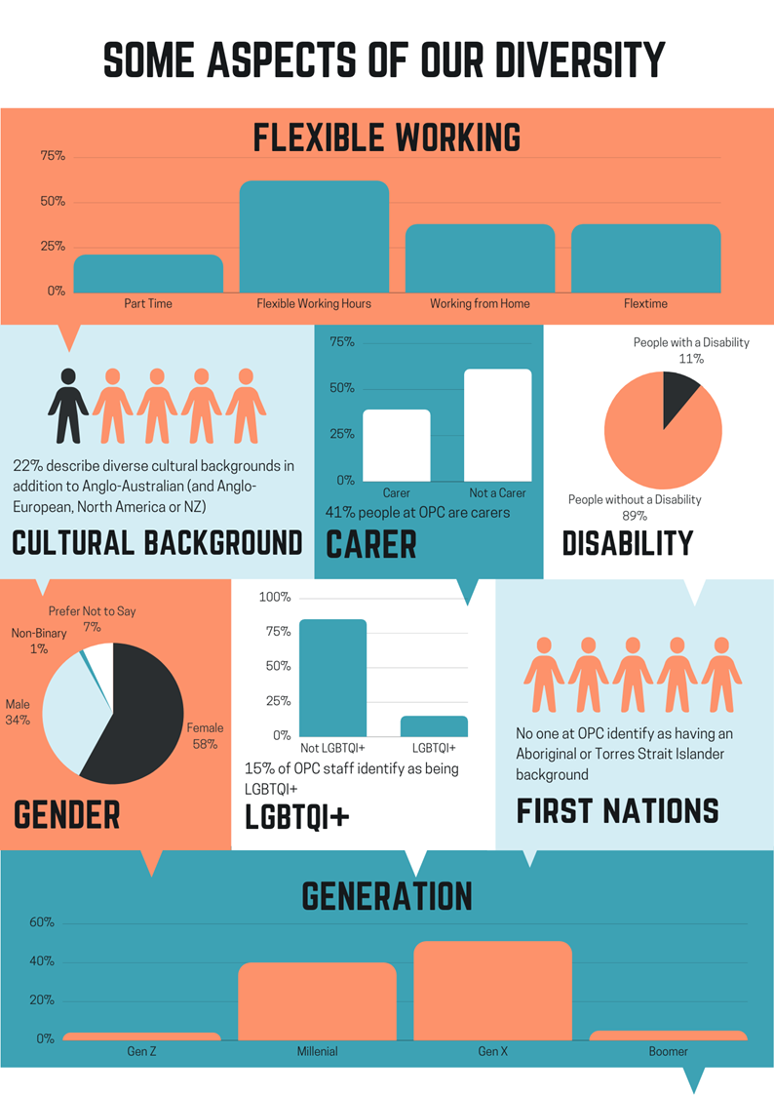

1. The APS Employee Census collects annual employee sentiment data from across the whole APS, and provides agencies the opportunity to ask agency specific questions. OPC’s results from 2023 compared with previous years and the APS in 2023 show a mix of trends in relation to diversity relevant questions.
2. OPC has improved in employee perception of our commitment to creating a diverse workforce. We have both improved, and are higher than the broader APS, in providing equal opportunities for all, in the absence of bullying, and in promoting an inclusive workplace culture.
3. Our result on consideration of flexible work requests is not significantly different over the last 3 years and remains higher than the APS.
4. We are slipping back and/or are lower than the APS in relation to promoting mental well-being, and supervisor action to actively ensure inclusion and the invitation of a range of views.
5. The Workplace Gender Equality Agency now reports on Australia’s gender pay gap across all sectors, including the APS. The gender pay gap data shown above is taken from APS Remuneration Survey data, which is collected as at 31 December of each year.
6. The gender pay gap is determined by taking the average of base salary for females, and for males, and expressing the difference as a percentage of the average male salary. A positive figure means that on average, males are paid more than females.
7. The graph above shows the APS wide gender pay gap is 6% in 2021 (the most recent published figure) and the OPC results of 10.9% in 2021 and 11.0% in 2022 (unpublished).
8. While it may appear that men are paid more than women, close examination of OPC data shows that, at the same classification and pay point, women and men are paid exactly the same.
9. The main driver of the OPC and APS gender pay gap is unequal representation of women and men across classifications. Both OPC and the APS are majority female, particularly at the lower classifications.

What we do now

1. Enacting our values, as well as the APS Code of Conduct and APS Values, we have embedded a range of practices that support inclusion.

Inclusion

* We have a strong and functional Consultation and Engagement strategy that provides opportunity for our people to express their views through the Workplace Consultative Committee, the People Committee, the Business Operations Committee, through various working groups such as the Joint Publications and Drafting Working Group, the IT co-design group, and the Reconciliation Action Plan working group.
* We have an active and inclusive social club, supporting a range of social activities.
* We celebrate the uniqueness of our people through a “getting to know…” section in our monthly all staff newsletter Corpbiz.
* Our Achieving Excellence and Capability performance management program focusses on ongoing feedback, recognition and growth and supports inclusion for all.
* We provide easy access to a range of flexible working options.
* Our internal Complaints policy includes inclusive practices.

Reconciliation

* We acknowledge and celebrate First Nations culture through acknowledgement of country and culture on email signature blocks; through celebrating NAIDOC week and recognising Sorry Day and Reconciliation Week; and through using graphics from our Indigenous artwork commissioned for our 50th anniversary.
* We actively support participation in the Jawun program, which offers our staff opportunity to learn from and support First Nations organisations.
* We have an active working group supporting the implementation of our 2023 Reflect Reconciliation Action Plan.

Mental well-being

* We promote R U OK Day and Mental Health Week.
* We have a comprehensive health and well-being program that promotes mental health. We have commenced engagement with the APSC Mental Health Capability Framework.
* We have, and continually build on, a range of strategies to address psychological safety, including promotion of appropriate conduct, strategies to reduce role overload, and sound job design.
* Our First Aid Officers are trained in Mental Health First Aid.
* We promote resources available in the community, such as Black Dog Institute, Beyond Blue, Headspace, etc.

Disability

* We promote International Day of People with a Disability.
* Our employment policies and practices comply with the anti-discrimination legislation, including providing reasonable adjustments for people with disability.
* For example, we have welcomed a mind-dog and raised awareness of his role, and held a presentation on the benefits of diversity, particularly neurodiversity.
* We regularly provide information on communicating effectively with people with hearing loss, from a colleague with lived experience and we have promoted effective communication with people who are deaf/hard of hearing and face-mask awareness.
* We provide assistive technology when needed, and ensure equitable treatment according to individual needs.
* We are members of the Australian Network on Disability, an network that assists employers to meet their legal obligations and to support employees with disability.

LGBTQI+

* We promote Pride Month and IDAHOBIT day.
* We are members of the AGD Pride network.

Gender

* We promote International Women’s Day, International Men’s day, and Wear it Purple Day (in support of non-binary genders).
* We voluntarily report on our gender pay gap.
* We maintain our accreditation as a Breastfeeding Friendly workplace.

Cultural and Linguistic Diversity

* We use social activities to celebrate diversity, such as ‘plate of origin’ morning teas to celebrate our cultural heritage and displaying world maps which visualise this.
* We promote Harmony Day.

Our strategy for the future

1. We have a solid foundation on which to build, as well as areas where our current strategies have not resulted in the broad representation we desire in our workforce. Our approach for the future is to be realistic about introducing strategies that will genuinely achieve our aim, and that we have the capacity to support and continue to embed.
2. Based on input from our People Committee and a review of our workforce data, the actions below extend our current embedded practices. We aim to introduce, embed, and maintain each new activity; and then build on it to introduce the next action area. Thus, the action areas below represent an order of priority and actions we have committed to implementing. As we prepare more detailed plans, such as the Reconciliation Action Plan and Mental Health Forward plan, further action items will be identified and implemented. The timeframes are of necessity flexible, as we pace our work with a range of strategic priorities and the capacity of our workforce to engage authentically with the work.

Inclusion

* + - Ensure that as we update our policies and practices, we identify and remove any systemic discriminatory or exclusionary requirements; or assumptions, oversights, or other barriers to inclusion. This will be achieved by ensuring that SMT consider barriers to inclusion in any policy that comes before it, and developing supporting tools to assist policy authors to identify and remove barriers.
    - Ensure that supervisors have inclusion competencies - authentic commitment, courage, cognisance of bias, curiosity, cultural intelligence and collaboration.
    - Ensure that our culture includes genuinely listening to individuals and giving proactive consideration to people’s views, even when their view diverge from a majority opinion.
    - Build capability of team leaders to ensure effective communication in all teams, so that people are kept ‘in the loop’ and decision-making is transparent.

Reconciliation

* + - Continue to implement the 2023 ‘Reflect’ Reconciliation Action Plan.
    - Build cultural capability in order to improve and embed the understanding of Aboriginal and Torres Strait Islander culture in the workplace to support the development of culturally-safe work spaces and services[4]. This may include indigenous language training or promotion.
    - Establish strong relationships with communities in regional and remote Australia to better understand the needs, priorities and goals of Aboriginal and Torres Strait Islander peoples and their communities[5].

Mental well-being

* + - Develop a psychosocial safety strategy to implement the Code of Practice “Managing psychosocial hazards at work”[6].
    - Develop and implement a forward plan as part of participation in APSC Mental Health Capability Framework, including an anti-stigma campaign.

Disability

* + - Invite people with disability and with mental health issues (including our workers or external speakers) to talk about their experiences.
    - Undertake regular external accessibility audits of our premises and IT systems.
    - Ensure employee training and induction is accessible to people with disability.

LGBTQI+

* + - Engage with programs such as Pride in Diversity.

Gender

* + - Continue to implement our Respect@Work project plan to prevent sexual harassment.
    - Review language and location of advertising for APS 4-6 positions to better attract male candidates.
    - Review and implement additional strategies from the Australian Public Service (APS) Gender Equality Strategy 2021-26.

Cultural and Linguistic Diversity

* + - Review recruitment ‘approach to market’ in order to be more attractive to people from culturally and linguistically diverse backgrounds.

Age

* + - Ensure that both younger and older workers have equitable access to career progression, and learning and development support.

Governance

1. OPC’s Diversity Champion (General Manager, Corporate) is responsible for promoting, supporting and enabling the achievement of the actions in our Strategy; and for maintaining our embedded practices.
2. In addition, the Diversity Champion will provide SMT with a report, every six months, on our diversity data, including APS Employee Census results; implementation of this strategy, and compliance with the related documents listed below.
3. OPC will report on our Diversity and Inclusion Strategy in our annual report.

Related documents

1. The following documents are related to this policy:
   1. *Public Service Act 1999*Under section 18 of the *Public Service Act 1999* (***PS Act***), FPC must establish a workplace diversity program to assist in giving effect to the APS Employment Principles. The relevant employment principles (paragraphs 10A(1)(f) and (g) of the PS Act) provide that ‘The APS is a career-based public service that…provides workplaces that are free from discrimination, patronage and favouritism; and recognises the diversity of the Australian community and fosters diversity in the workplace.’
   2. Commonwealth Aboriginal and Torres Strait Islander Workforce Strategy 2020-24
   3. Australian Public Service (APS) Gender Equality Strategy 2021-26
   4. Australian Public Service Disability Employment Strategy 2020-25

Review

1. This strategy will be reviewed at least annually.

Meredith Leigh

First Parliamentary Counsel

October 2023

| **Document History** | | |
| --- | --- | --- |
| **Release number** | **Release date** | **Document number** |
| 1.0 | March 2010 | s09am208.v05.docx |
| 2.0 | October 2012 | s09am208.v07.docx |
| 3.0 | June 2013 | s09am208.v09.docx |
| 3.1 - Renumbering only | August 2017 | s09am208.v13.docx |
| 4.0 | July 2022 | S22TP263.v06.docx |
| 5.0 | 20 October 2023 | S22TP263.v10.docx |

Note: Before July 2022, this Strategy was called OPC No.57 Workplace Diversity Program. Before May 2017, this OPC was called Office Procedural Circular No. 63. In July 2022, this Strategy incorporated information that was previously covered by OPC 5.9 Equal treatment of same-sex couples and their families and OPC 5.8 Disability Awareness.

1. See https://www.vic.gov.au/understanding-intersectionality
2. NSW Public Service Belonging and Inclusion Strategy, viewed at https://www.psc.nsw.gov.au/sites/default/files/2022-02/15812_NSW%20PSC_Belonging%20Strategy%202022_v2_ACCESSIBLE.pdf
3. Nolan-Flecha, N (2018) “Next generation diversity and inclusion policies in the public service” OECD Working Paper on Governance No. 34 p8.
4. https://www.apsc.gov.au/sites/default/files/2021-03/commonwealth_aboriginal_and_torres_strait_islander_workforce_strategy_2020_-24_0.pdf p 21
5. https://www.apsc.gov.au/sites/default/files/2021-03/commonwealth_aboriginal_and_torres_strait_islander_workforce_strategy_2020_-24_0.pdf p 18
6. https://www.safeworkaustralia.gov.au/sites/default/files/2022-08/model_code_of_practice_-_managing_psychosocial_hazards_at_work_25082022_0.pdf