Word Note No. 3.6  
Formulas

Document release 5.2

Updated July 2016

Contents

Introduction 1

To insert a new formula 2

Step 1—Open MathType 2

Step 2—Create equation format 2

Step 3—Replace dummy text 2

Step 4—Close MathType 2

Special notes 3

Placing the insertion point 3

Do not copy formulas from other Bills 3

To edit an existing formula 3

Spacing 3

Green formatting boxes 4

Apostrophes and asterisks 4

Brackets and braces 4

Width of formulas 5

Formula does not appear in the document 5

Further assistance 5

Attachment A — Step‑by‑step examples 7

Example 1 — Creating the equation format for a single‑line formula 7

Example 2 — Creating the equation format for a multiple‑line formula 8

Introduction

1. All formulas to be included in legislation and other instruments, including one‑line formulas, are to be produced using the MathType equation editor program.
2. To simplify the creation of formulas, a toolbar has been created for MathType. All equations are generated by combining the options available on the toolbar.
3. For formatting rules about formulas, please refer to Word Note No. 4.2.

To insert a new formula

Step 1—Open MathType

1. Position the cursor where you want to insert the formula. If the cursor is not on a blank line, the macro will start a new line.
2. 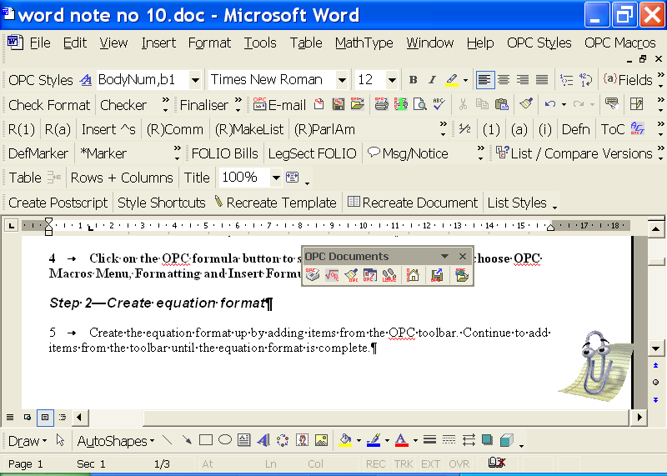Click on the OPC formula button (see right) on the Tools group on the OPC tab of the Word Ribbon to start MathType.
3. Alternatively, go to OPC Macros menu, Formattingsub‑menu and choose Insert Formula.

Step 2—Create equation format

1. Create the equation format up by adding components from the OPC tab on the MathType formula toolbar pictured below.

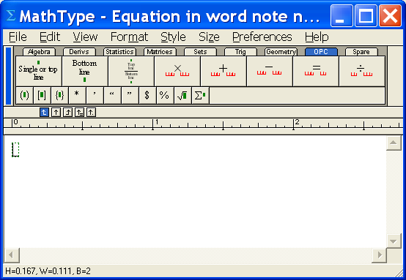

1. Add components for the formula from the toolbar until the equation format is complete (see Attachment A for step‑by‑step examples of how to build a formula).
2. Where components are in brackets, insert the brackets first. See paragraphs 36 to 38 for more information.
3. Where possible, click the buttons provided on the toolbar because they contain the correct spacing. If a component you use is not on the toolbar, see the IT staff.

Step 3—Replace dummy text

1. Edit each text component to replace the dummy text with the words required in the formula. Be careful not to delete spaces between components.
2. Do not delete empty green boxes above or below text, as these are important for correct spacing. See paragraphs 28 to 30 for further information.
3. All text in formulas should be centred. If your text is not centred, then select the text and press Ctrl+Shift+J to centre the text.
4. If you need to include an apostrophe or asterisks in your formula, please read paragraphs 31 to 35 for more information.

Step 4—Close MathType

1. To save the formula, choose “Close and Return to...” from the MathType File menu, or simply close the dialog box. This will prompt you save changes to the formula and, if you answer “Yes”, it will put the formula into the Word document at the cursor position.
2. The formula will be pasted into the Word document where the insertion pint is, and will not change the style of the paragraph it is inserted into.

Special notes

Placing the insertion point

1. The location of the insertion point within a formula is very important when you are building or editing a formula.
2. When you are replacing the dummy text, make sure that the insertion point is within the text to be replaced, and not outside the component.
3. Pressing the TAB key will usually move the insertion point to the end of the next component in the equation. Also, you can place the insertion point within the text in any component by positioning the mouse pointer over the desired position, and clicking.
4. The examples in Attachment A of this Word Note show when to press the TAB key to move to the next component.

Do not copy formulas from other Bills

1. When creating formulas in legislation or other instruments, please do not copy them from other legislation or instruments even if the formulas are the same. You should always create them from scratch.
2. The reason for this is that formulas from old documents can corrupt a new document causing Word to crash.

To edit an existing formula

1. Just double‑click on the formula in Microsoft Word to edit it in Mathtype. If the formula does not open in Mathtype, you will need to delete it and create it again in Mathtype.

Spacing

1. You should always have 3 spaces between a formula component and an operator (+, ‑ etc.). This is an example of the 3 spaces on both sides of a subtraction operator裰矺㡰矵䒨矹絰矵診矵㳴ړꢈณ.
2. These spaces are built into the buttons on the OPC tab of the MathType toolbar so there should be no need to insert the spaces manually. There should also not be any spaces between a bracket and the text inside it e.g. (dog).
3. Below is an example of a formula with multiplication and subtraction operators.



Note: In the above example the keyboard was used to create parentheses around text within a component of the formula. The keyboard parenthesis is not to be used in formulas around a complete component of a formula.

1. It is a good idea to have Show All turned on in MathType (under View menu) so that you can see that the 3 red spaces are surrounding each operator.

Green formatting boxes

1. If you have Show All turned on, then you should see a small green box 裰矺㡰矵䒨矹絰矵診矵ᱴ౯顐ڪ above each single line component, below each bottom line component, and above and below each top/bottom line component.
2. An example of a formula showing both the spaces and the green formatting boxes is as follows:

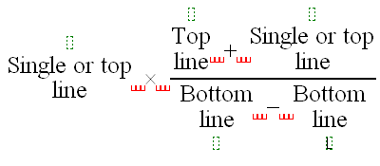

1. Do NOT delete any of these small green boxes.

Apostrophes and asterisks

1. If you have an apostrophe in your formula, you must insert it by clicking the apostrophe on the small button on the OPC tab of the MathType toolbar, not the one on the keyboard.
2. Similarly, to insert an asterisk you need to click the asterisk on the toolbar and not use the keyboard.
3. Below is an example of a formula with apostrophes and asterisks.



1. You should insert all text without any of the asterisks and then go back and place the cursor in the appropriate spot and click the * on the toolbar, not the keyboard.
2. Note: if you try to insert the asterisks as you go then all the following text will be in smaller font.

Brackets and braces

1. Do not use the keyboard to add mathematical brackets or braces.
2. Below is an example of a formula with brackets inserted using the buttons on the OPC tab on the MathType toolbar.



1. Example of a formula with square brackets inserted by clicking the square bracket button on the OPC tab of the MathType toolbar.



Width of formulas

1. Make sure that your formula is never too wide to fit onto the page. If it is, it may automatically resize itself to fit on the page. If this occurs, you should start again from scratch making sure that it is narrower (by putting more returns in the various components).
2. To check that the formula has not been re‑sized, right click on the formula in Word and click the Format Object option from the pop-up menu. In the Format Object dialog, click the Size tab, and check the Scale Height and Width are set to 100%.
3. Formulas should not exceed the left or right text margins. If your formula is too wide to fit within in the right hand text margin, see Word Note 4.2.

Formula does not appear in the document

1. This error arises when you create a formula in MathType but, when you close and return to Word, the formula does not appear. This is caused by the line height being too small. To fix the problem, re-apply the style to the paragraph the formula is in.

Further assistance

1. If you have problems or wish to create a formula with a feature not described here (e.g. superscript or subscript number), please see a member of the IT staff.

Andrew Newbery

IT Director

| **Document History** | | |
| --- | --- | --- |
| **Release number** | **Release date** | **Document number** |
| 1.0 | 20 April 2006 | s05pu364.v01.doc |
| 2.0 | 24 April 2006 | s05pu364.v03.doc |
| 3.0 | 26 July 2006 | s05pu364.v04.doc |
| 4.0 | 03 August 2006 | s05pu364.v05.doc |
| 5.0 | 17 August 2006 | s05pu364.v06.doc |
| 5.2 - renumbered and updated | 27 July 2016 | s05pu364.v12.docx |

Note: Before the renumbering of the current series of Word Notes, this Word Note was known as Word Note (No. 10), also called Word Note 10.

Attachment A — Step‑by‑step examples

This attachment describes how to create the equation format for a single‑line formula and a multi‑line formula. The equations are built from left to right, clicking the buttons from the OPC tab of the MathType toolbar and moving the insertion point with the TAB key when necessary.

Example 1 — Creating the equation format for a single‑line formula

This example will create the equation format for the following formula:



1. Insert the curved brackets by clicking the small button with curved brackets on the OPC tab of the MathType toolbar.
2. Insert the components inside the brackets by clicking the following large buttons on the OPC tab of the MathType toolbar.
   1. click the **Single or top line** button
   2. press the TAB key to move to the next component
   3. click the **Subtraction** button
   4. click the **Single or top line** button



1. Press the TAB key twice to move outside the curved brackets and click the following large buttons on the OPC tab of the MathType toolbar:
   1. click the **Multiplication** button
   2. click the **Single or top line** button
   3. press the TAB key to move to the next component
   4. click the **Multiplication** button
   5. click the **Single or top line** button
   6. press the TAB key to move to the next component
   7. click the **Equal** button
   8. click the **Single or top line** button



Example 2 — Creating the equation format for a multiple‑line formula

This example will create the equation format for the following formula:

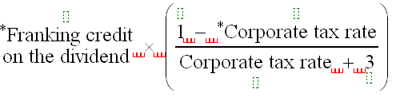

1. Insert the left‑hand‑side components by clicking the following large buttons on the OPC tab of the MathType toolbar.
   1. click the **Single or top line** button
   2. press the TAB key to move to the next component
   3. click the **Multiplication** button
2. Insert the curved brackets by clicking the small button with curved brackets on the OPC tab of the MathType toolbar.



1. Insert the components inside the brackets by clicking the following large buttons on the OPC tab of the MathType toolbar.
   1. click the **Top line over Bottom** **line** button
   2. press the **TAB** key to move to the next component
   3. click the **Subtraction** button
   4. click the **Single or a top line** button



1. The cursor is now located on the top line of the formula. Press the TAB key 5 times to move the cursor to the right of the bottom line inside the brackets.
2. Insert the extra components in the bottom line of the formula by clicking the following large buttons on the OPC tab of the MathType toolbar.
   1. click the **Addition** button
   2. click the **Bottom line** button

